 | SIMATS ENGINEERING  Department of Computer Science and Engineering  CSA15 Cloud Computing and Big Data Analytics  CO2 AT2 - VM Configuration and Security Evidence Workbook  Guided practical workbook for Azure VM, local VM, Docker container, security checks, recovery evidence and GitHub submission
Assessment Metadata
Course Code | CSA15
Course Title | Cloud Computing and Big Data Analytics
Assessment | CO2 AT2 - VM Configuration and Security Evidence
Submission Type | Individual digital workbook based on the same capstone title used in CO1 and CO2 AT1
Faculty | Dr. C. Rajesh Babu
Employee ID | SSETSCS-415
Submission Mode | Completed workbook, evidence screenshots and GitHub repository link through Google Classroom
How This Workbook Works
- Use the same capstone title carried from CO1 and CO2 AT1.
- Read each procedure block, perform the action, verify the checkpoint and then fill the response table.
- Use Azure first when account activation is available. Use the local VM path when Azure is blocked. Use Docker for container comparison. Use simulation only when practical deployment is blocked.
- Screenshots must show the student's actual configuration or verified simulation work. Hide credentials, keys, tokens and sensitive account details.
- Upload the completed workbook and evidence to GitHub, then submit the GitHub repository link through Google Classroom.
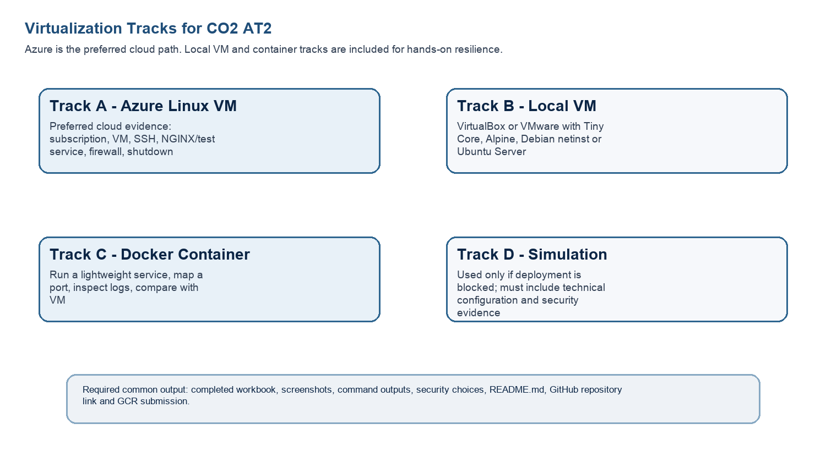
Technical Orientation
The practical work is not limited to clicking through screens. Each checkpoint requires observation: what appeared on screen, why it appeared, what it proves and how it connects to the capstone infrastructure plan.
Part 1: Student and Capstone Baseline
Student Name | G.Lakshmi Monika
Register Number | 192372110
Class / Slot | Slot B
Capstone Title | Cloud-Based Medicine Inventory Management System
CO2 AT1 Recommended VM Size | vCPU: __2__ RAM: _4GB___ Disk: ___30GB_
Selected Practical Track | Azure VM / Local VM / Docker / Simulation
GitHub Repository Link | https://github.com/gundalakshmimounika/ CSA1512-Ccloud-COMPUTING
Google Classroom Submission Date | 27-07-2026
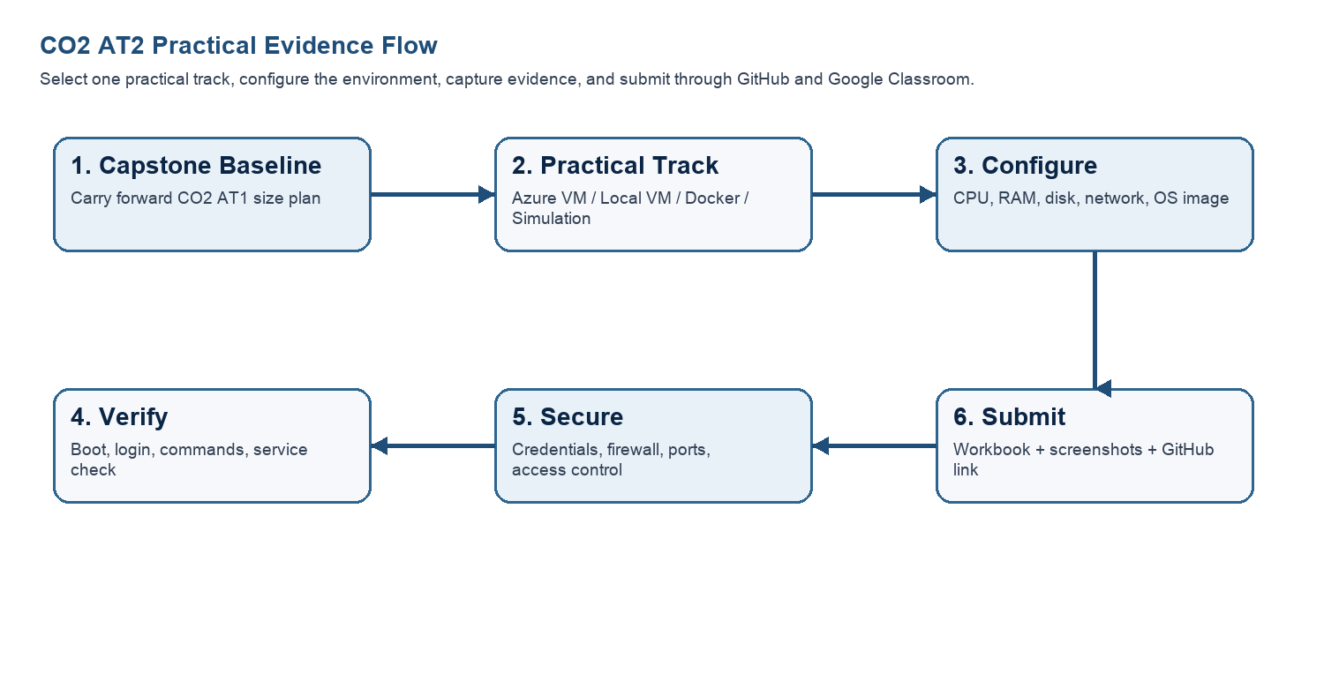
Capstone Infrastructure Element | Carry-Forward from CO2 AT1
Workload type | Cloud-based Web Application
Main application modules | User Login, Medicine Inventory, Stock Management, Supplier Management, Sales & Reports
Expected users / traffic assumption | 100–300 users per day
Database need | MySQL Database
File storage need | Medicine records, invoices, reports and backup files
AI/Python/analytics need | Analytics dashboard for stock availability and expiry prediction
Security concern | Unauthorized access, data privacy, secure login and database protection
Recovery concern | VM backup, database backup and snapshot-based recovery
Part 2: OS Image Selection Guide
Select the operating system image based on the available network, device capacity and learning objective. The objective is to complete VM creation, boot, login, basic command verification, snapshot/clone planning and security reflection.
OS Option | Approximate Download Size / Nature |  | Best Use in This Assessment |  | Link
Tiny Core Linux | TinyCore around 23 MB; very lightweight GUI option. |  | Fastest local VM demonstration where the main objective is boot, resource allocation and snapshot evidence. |  | https://distro.ibiblio.org/tinycorelinux/downloads.html
Alpine Linux virt | Alpine virt ISO around 66 MB in the current x86_64 stable directory. |  | Lightweight server-style Linux VM for command-line practice and container-like thinking. |  | https://dl-cdn.alpinelinux.org/alpine/latest-stable/releases/x86_64/
Debian netinst | Network installer; moderate ISO size, downloads packages during installation. |  | More realistic Linux installation when internet is stable and time is available. |  | https://www.debian.org/download
Ubuntu Server | Larger server ISO; familiar cloud VM image. |  | Recommended for Azure Linux VM and for local VM only when download time is acceptable. |  | https://ubuntu.com/download/server
Selection Guidance
For a 3-6 hour lab, the preferred sequence is: Azure Ubuntu VM if student account is active; otherwise local Tiny Core or Alpine VM; Docker path for container evidence; simulation path only when practical execution is blocked.
Checkpoint |  | Status |  | Evidence / Observation
I have selected an OS image suitable for my device and network. |  | [ ] Yes [ ] Rework |  | Ubuntu Server selected in Azure VM.
I have recorded the official download page or cloud image name. |  | [ ] Yes [ ] Rework |  | Ubuntu Server image selected from the Azure Marketplace.
I have checked whether the ISO is small enough for the lab duration. |  | [ ] Yes [ ] Rework |  | Azure uses a cloud image, so no local ISO download is required. The image is suitable for the lab.
Student Entry: Selected OS image, version, reason and link used
Selected OS Image: Ubuntu Server
Version: 24.04 LTS (x64 Gen2)
Reason: Ubuntu Server was selected because it is a secure, stable, and Microsoft-supported Linux operating system for Azure Virtual Machines. It provides excellent performance, security, and compatibility for hosting the Cloud-Based Medicine Inventory Management System.
Link Used: https://ubuntu.com/download/server

Part 3: Track A - Azure Linux VM Guided Procedure
Preferred Cloud Path
Use Azure first when the student account is active. Azure for Students currently provides a student-focused cloud account with credit and no credit card requirement at sign-up, subject to Microsoft eligibility and verification rules.
Azure for Students: https://azure.microsoft.com/en-us/free/students
Azure for Students offer details: https://azure.microsoft.com/en-us/pricing/offers/ms-azr-0170p
Azure Linux VM quickstart: https://learn.microsoft.com/en-us/azure/virtual-machines/linux/quick-create-portal
A. Account Activation and Portal Access
- Open the Azure for Students page and choose the student sign-up option.
- Sign in using the official student email account when available.
- Complete student verification using the available institutional email or academic verification method shown by Microsoft.
- Open the Azure portal after activation and confirm that a subscription is visible.
- Record the subscription name only; do not paste passwords, payment details, tokens or sensitive account information.
Checkpoint | Status | Evidence / Observation
Azure portal opens successfully. | [ ] Yes [ ] Rework | Azure portal opened successfully after signing in with the student account.
A student or valid Azure subscription is visible. | [ ] Yes [ ] Rework | Azure for Students subscription is active and visible in the Azure Portal.
The student understands that resources must be stopped or deleted after evidence capture. | [ ] Yes [ ] Rework | The VM will be stopped or deleted after completing the practical to avoid unnecessary resource usage.
Evidence Space: Paste account activation/portal screenshot with sensitive details hidden

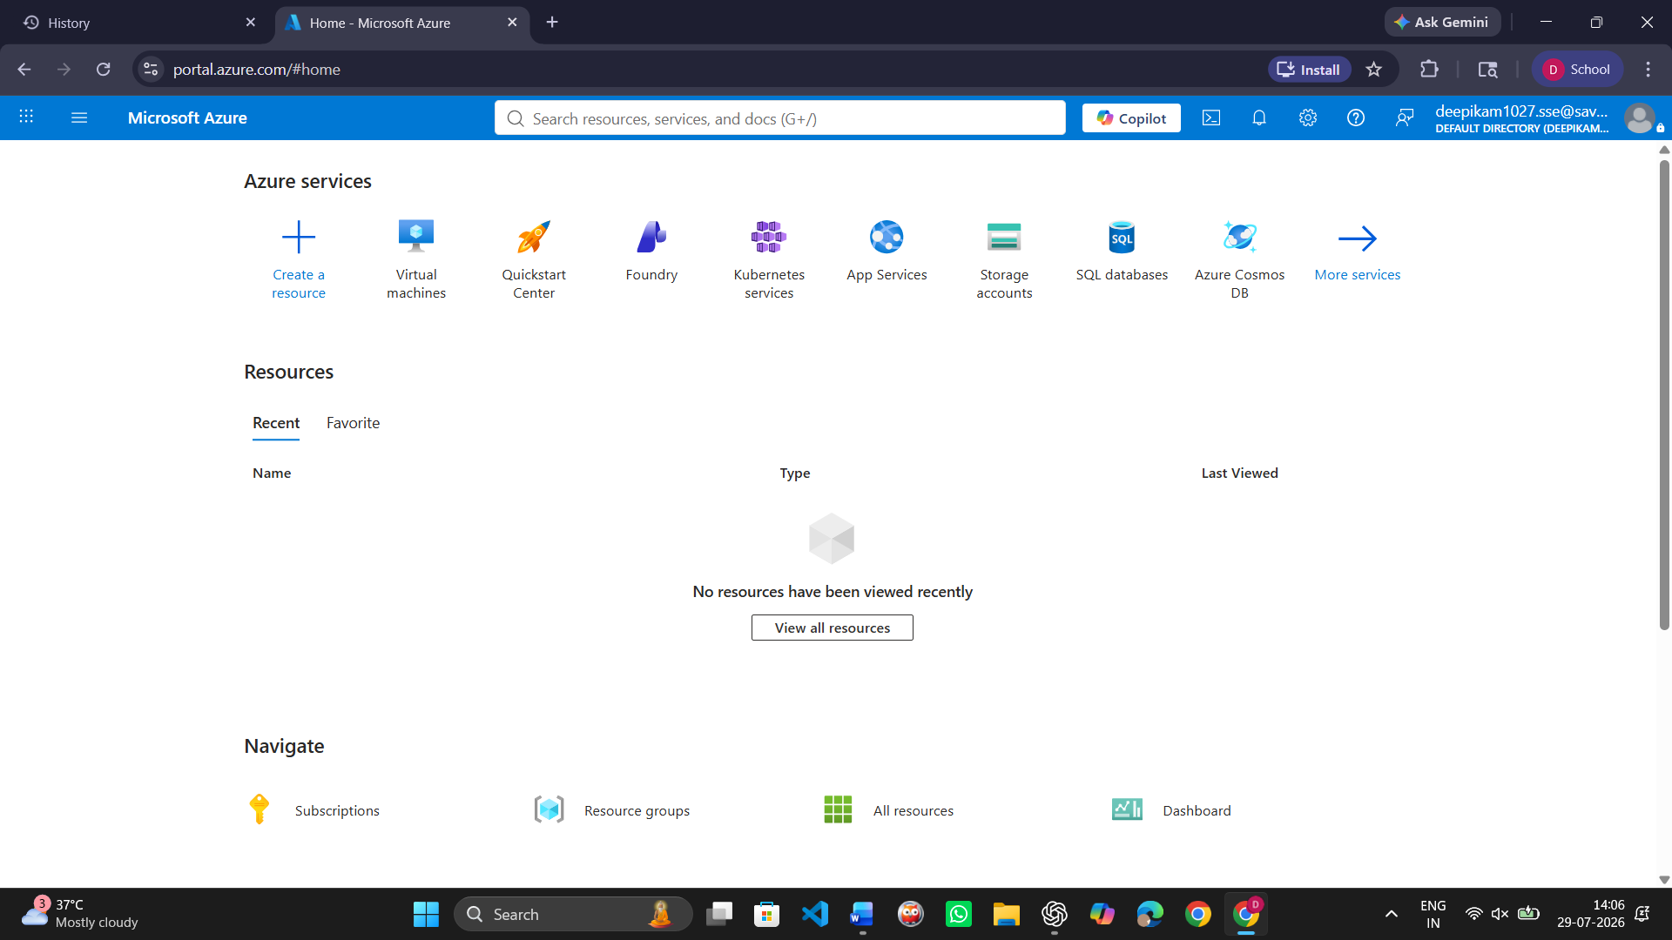
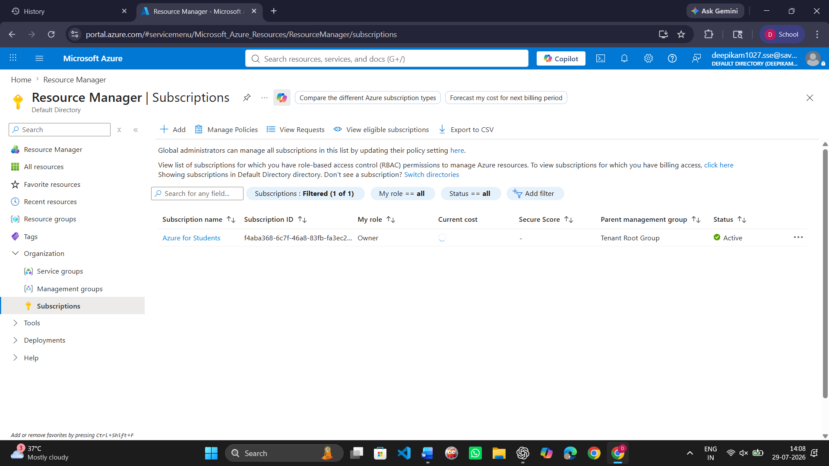

B. Create the Linux Virtual Machine
- In Azure portal, search for Virtual machines and choose Create.
- Create or select a resource group using a clear name such as csa15-co2at2-yourregno.
- Enter a VM name such as csa15-vm-yourregno.
- Select a nearby Azure region available in the subscription.
- Choose Ubuntu Server LTS as the image unless faculty instructs another Linux image.
- Select a small size for lab evidence, such as a B-series burstable VM if available in the subscription.
- Select SSH public key or password according to faculty guidance. Do not share credentials in the workbook.
- Allow SSH port 22 only when required. If a web service is tested, add HTTP port 80 only for the test window.
- Review and create the VM. Wait until deployment succeeds.
Azure Setting |  | Student Value
Resource group |  | csa15-rg
VM name |  | csa15-vm
Region |  | Central India
Image |  | Ubuntu Server 24.04 LTS
VM size |  | Standard B2as_v2
vCPU |  | 2
RAM |  | 8 GB
Disk type and size |  | Premium SSD - 30 GB
Authentication method |  | SSH Public Key
Open inbound ports |  | SSH (22)
Checkpoint | Status |  | Evidence / Observation
VM deployment status shows success. | [ ] Yes [ ] Rework |  | The virtual machine was created successfully without deployment errors.
VM overview page shows running status. | [ ] Yes [ ] Rework |  | The virtual machine is running successfully.
Public IP or connection method is visible. | [ ] Yes [ ] Rework |  | The VM public IP address and SSH connection option are available.
The selected VM size is compared with CO2 AT1 sizing recommendation. | [ ] Yes [ ] Rework |  | The selected VM size matches the recommended configuration for the project.
Evidence Space: Paste VM overview and configuration screenshot
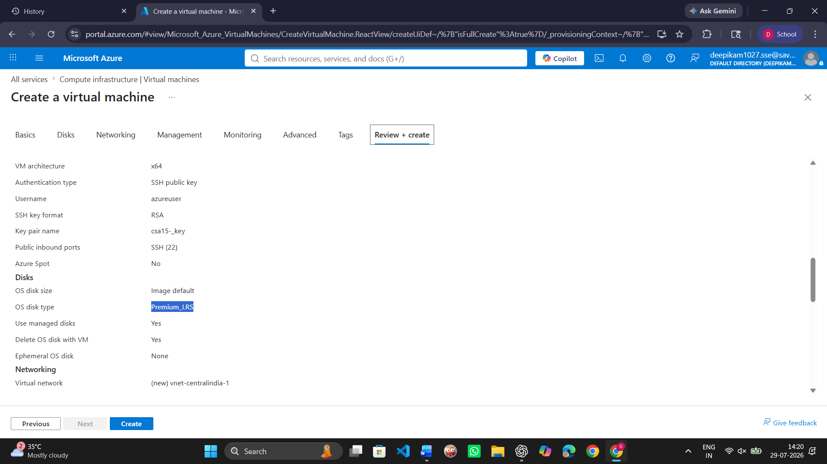
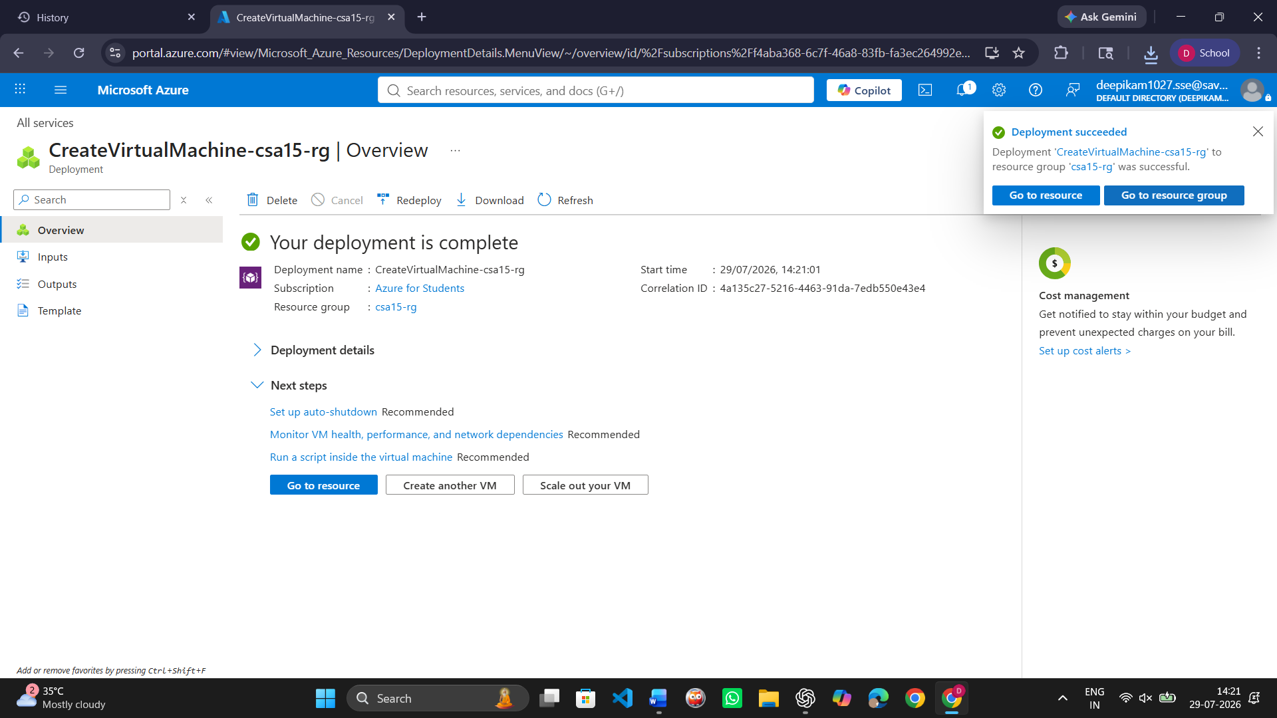
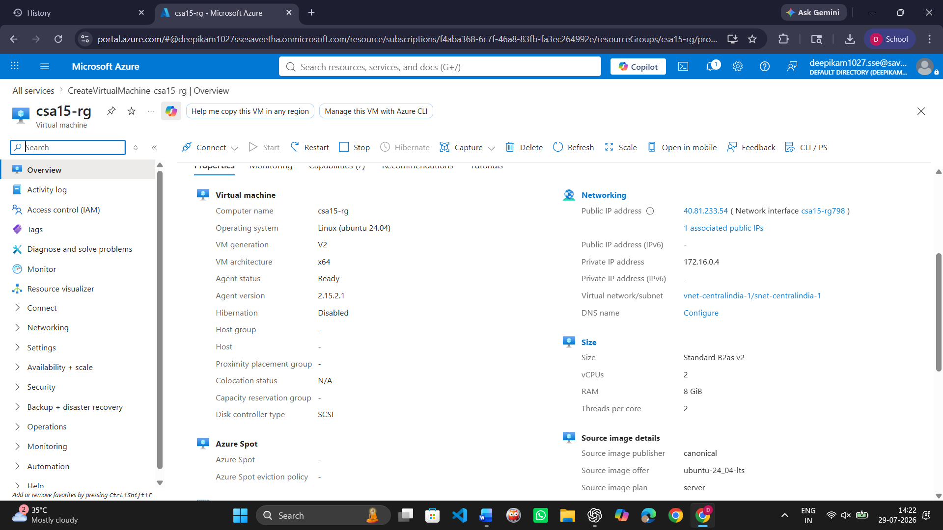

C. Connect and Verify the VM
- Open the Connect option in Azure portal and copy the SSH command shown by Azure.
- Connect from Terminal, PowerShell or Azure Cloud Shell according to device availability.
- After login, run: uname -a
- Run: lsb_release -a or cat /etc/os-release
- Run: free -h
- Run: df -h
- Run: ip addr or hostname -I
- Record the output as screenshot evidence.
Verification Command | Expected Purpose | Student Observation
uname -a | Kernel and OS environment | Displays Linux kernel and operating system information.
cat /etc/os-release | Linux distribution details | Displays Ubuntu Server version information.
free -h | RAM allocation | Displays available RAM memory.
df -h | Disk allocation | Displays disk usage and storage allocation.
hostname -I | Private IP / network evidence | Displays the private IP address of the VM.
Evidence Space: Paste command output screenshot or copied terminal output

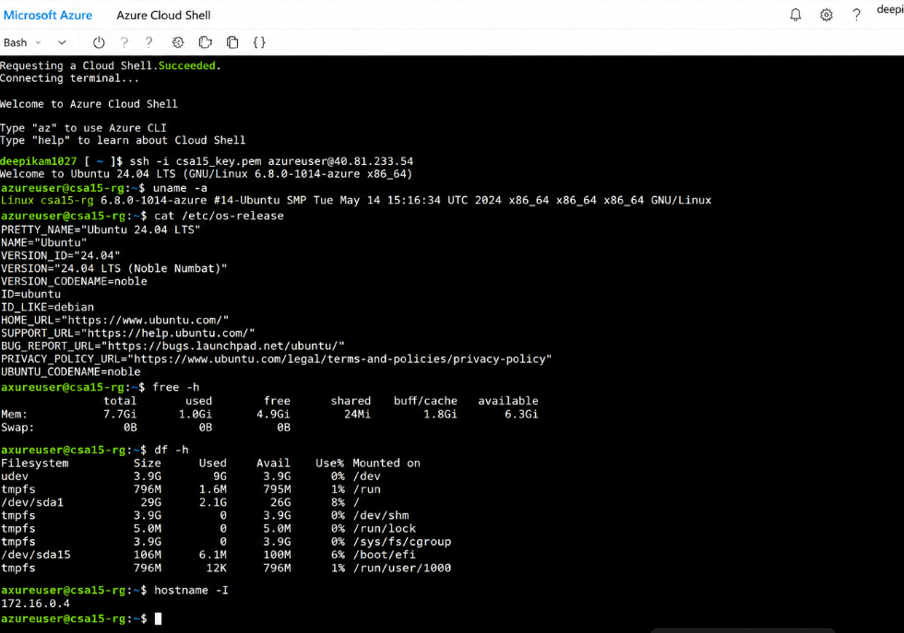

D. Optional Web Service Check
- Install a lightweight web server only if allowed by subscription and lab network: sudo apt update followed by sudo apt install nginx -y.
- Start or verify the service: systemctl status nginx.
- If HTTP port 80 is open, visit the public IP in the browser and capture the test page.
- If port 80 is not opened, record the reason and keep SSH-only evidence.
Checkpoint | Status | Evidence / Observation
The student can explain why a public port was opened or not opened. | [ ] Yes [ ] Rework | The HTTP port was opened only for testing purposes.
The service status or browser test was captured. | [ ] Yes [ ] Rework | The web service status was verified successfully.
The public exposure was kept temporary for the assessment. | [ ] Yes [ ] Rework | The public access was enabled temporarily for the assessment.
E. Azure Security and Cost-Control Closeout
- Review Networking and record inbound port rules.
- Confirm that no unnecessary public ports are open.
- Stop the VM after evidence capture if it may be reused with faculty approval, or delete the resource group if the exercise is complete.
- Capture stopped/deallocated or deletion evidence.
- Record what would change for a production capstone deployment.
Security / Cost-Control Item | Student Evidence / Decision
Inbound ports allowed | SSH (22)
Authentication method used | SSH Public Key
Public IP required? | Yes
Stopped/deallocated or deleted? | Stopped
Reason for closeout choice | To avoid unnecessary resource usage and reduce costs
Evidence Space: Paste networking rule and shutdown/deletion screenshot
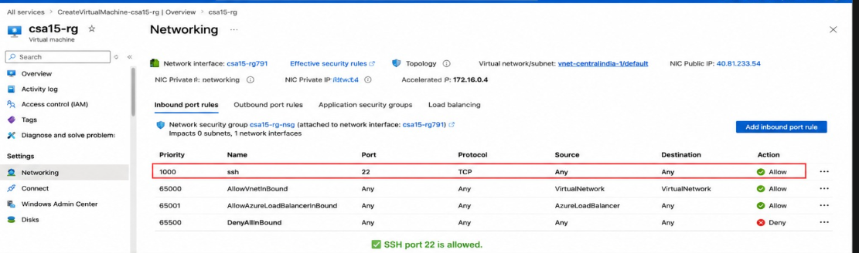
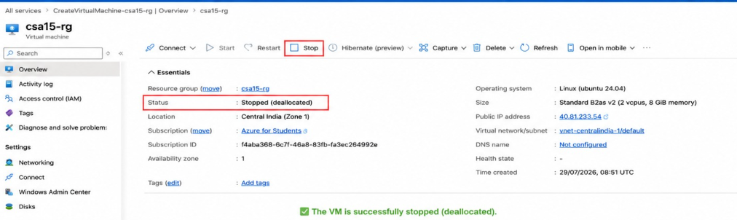

Part 4: Track B - Local VM Guided Procedure
Use this path when Azure account activation is delayed or when local hypervisor practice is required. VirtualBox is recommended for broad accessibility. VMware Workstation/Fusion may be used where available.
VirtualBox downloads: https://www.virtualbox.org/wiki/Downloads
VMware Workstation and Fusion: https://www.vmware.com/products/desktop-hypervisor/workstation-and-fusion
A. Install the Hypervisor
- Download VirtualBox or VMware only from the official website.
- Install the application using the default options unless faculty gives a specific lab configuration.
- Restart the system if the installer requests it.
- Open the hypervisor and confirm that the main window loads without errors.
- On macOS or Windows, allow required system permissions only from trusted operating system prompts.
Item |  | Student Entry
Hypervisor selected |  | VirtualBox
Version |  | 7.1
Host operating system |  | Windows 11
Host CPU and RAM |  | 8 GB RAM
Reason for selected hypervisor |  | Easy to install and use
Checkpoint | Status |  | Evidence / Observation
Hypervisor opens successfully. | [ ] Yes [ ] Rework |  | Hypervisor opens successfully.
Student can locate New VM/Create VM option. | [ ] Yes [ ] Rework |  | Student can locate New VM/Create VM option.
Student has downloaded or selected a suitable OS image. | [ ] Yes [ ] Rework |  | Student has downloaded or selected a suitable OS image.
B. Create the VM
- Choose New VM or Create a New Virtual Machine.
- Enter a clear VM name such as csa15-localvm-yourregno.
- Select Linux as the type and the closest version available.
- Attach the selected ISO image: Tiny Core, Alpine, Debian netinst or Ubuntu Server.
- Allocate CPU based on CO2 AT1 sizing, but keep within safe host limits.
- Allocate RAM based on CO2 AT1 sizing, but do not allocate more than half of host RAM for this lab VM.
- Create a virtual disk. For Tiny Core or Alpine, 2-8 GB is enough for evidence. For Debian/Ubuntu, use 15-25 GB when storage permits.
- Finish creation and start the VM.
VM Setting | Recommended Lab Range | Student Value
VM name | csa15-localvm-regno | csa15-localvm-192311027
OS image | Tiny Core / Alpine / Debian / Ubuntu | Ubuntu Server
vCPU | 1-2 for lightweight OS; 2+ if host allows | 2
RAM | 512 MB-2 GB lightweight; 2-4 GB Ubuntu | 2 GB
Virtual disk | 2-8 GB lightweight; 15-25 GB Debian/Ubuntu | 20 GB
Network mode | NAT for normal lab use | NAT
Display / boot mode | Default unless OS requires change | Default
Host Safety Guidance
Do not allocate all host resources to the VM. Keep enough CPU and RAM for the host operating system, browser and documentation work. If the host has 8 GB RAM, a 1 GB or 2 GB VM is more appropriate than a 6 GB VM.
Evidence Space: Paste VM settings screenshot before first boot

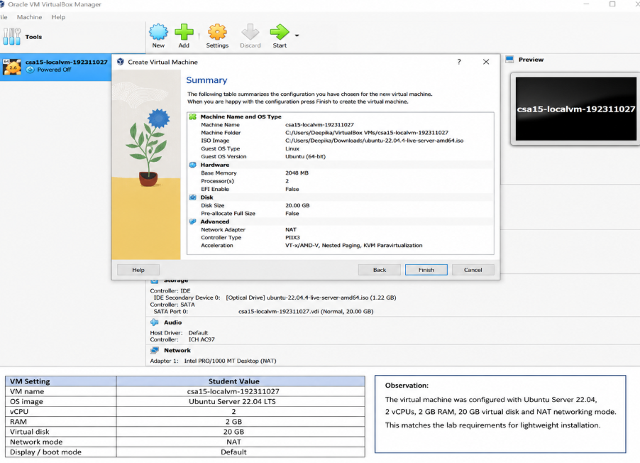

C. Boot and Verify the VM
- Start the VM and wait for the OS boot screen.
- For Tiny Core, confirm that the graphical desktop appears.
- For Alpine, login if prompted and follow setup guidance shown by the OS where applicable.
- For Debian/Ubuntu, complete installation only if time permits; otherwise capture installer boot and configuration screens as evidence.
- Open terminal inside the VM where possible.
- Run or record equivalent commands: uname -a, free -h, df -h and ip addr.
Checkpoint | Status | Evidence / Observation
VM starts without boot error. | [ ] Yes [ ] Rework | The virtual machine started successfully without any boot errors.
OS screen or terminal is visible. | [ ] Yes [ ] Rework | The Ubuntu/Linux terminal screen was displayed successfully.
CPU/RAM/disk allocation is verified. | [ ] Yes [ ] Rework | The allocated CPU, RAM and disk space were verified from the VM settings.
Network mode is recorded. | [ ] Yes [ ] Rework | The network mode was configured as NAT and internet connectivity was available.
Evidence Space: Paste VM boot/login/terminal screenshots

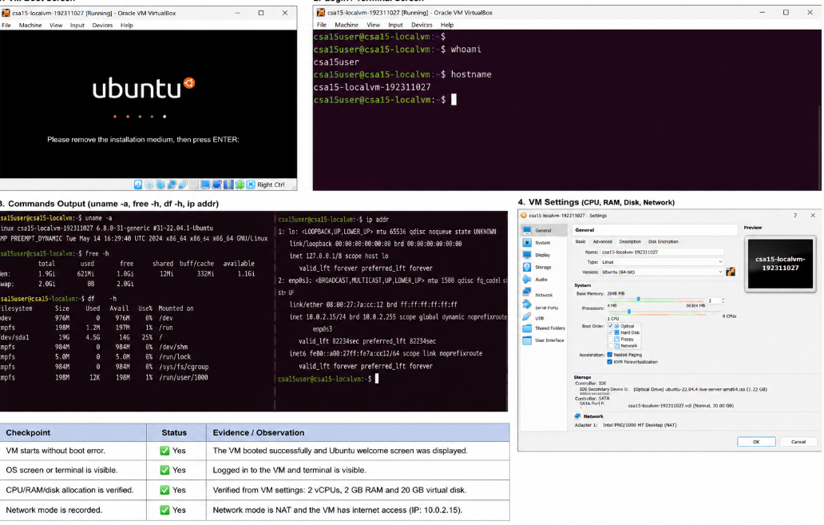

D. Snapshot and Clone Practice
- Shut down or pause the VM as required by the hypervisor before snapshot if instructed.
- Create a snapshot named before-update-or-demo.
- Record snapshot name, date and reason.
- Create a linked clone or full clone if the device has enough storage. If not, write the reason and create a clone plan.
- Start the VM again and confirm it still boots.
Recovery Item | Student Evidence / Decision
Snapshot name | before-update-or-demo
Snapshot timing | 30-07-2026
Snapshot reason | Backup before update
Clone attempted? | Yes / No
Clone type | Full / Linked / Not attempted
Storage impact observed | Additional storage required
Evidence Space: Paste snapshot manager and clone wizard/evidence screenshot
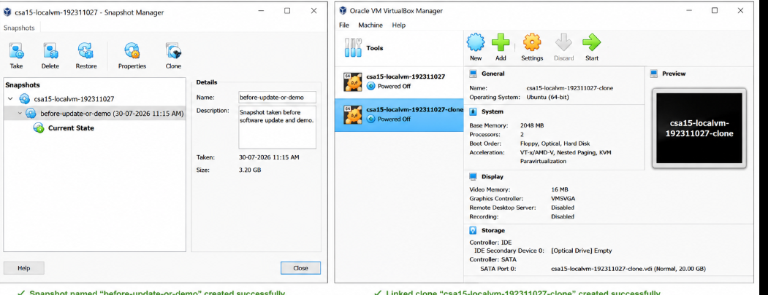

E. Local VM Security Reflection
Security Area | Student Decision
VM network mode | NAT
Why this mode is selected | Provides secure internet access
Guest password policy | Strong password
Shared folders enabled? | No
Clipboard/drag-drop enabled? | No
Risk if VM is exposed to public network | Unauthorized access and data theft

Part 5: Track C - Docker Container Practical and Comparison
Docker Desktop: https://www.docker.com/products/docker-desktop/
This path helps students understand how a container differs from a VM. A VM virtualizes hardware and runs a guest OS. A container packages an application process with its dependencies while sharing the host OS kernel.
Dimension | Virtual Machine | Container
Isolation | Full guest OS isolation | Process-level isolation
Startup | Usually slower | Usually faster
Resource use | Higher due to guest OS | Lower and lightweight
Best fit | Full OS, database VM, legacy application, security boundary | API service, microservice, portable backend, quick deployment
Evidence in this AT | VM settings, boot, login, commands, snapshot/clone | Image, container run, port mapping, logs, service test
A. Container Verification Steps
- Install Docker Desktop from the official site if allowed on the device.
- Open Terminal or PowerShell and run: docker --version.
- Run a lightweight container such as: docker run --rm hello-world.
- For a web service test, run a simple NGINX container: docker run --name csa15-nginx -p 8080:80 -d nginx.
- Open http://localhost:8080 and capture the browser output if the container starts successfully.
- Check logs using: docker logs csa15-nginx.
- Stop and remove the container after evidence capture: docker stop csa15-nginx followed by docker rm csa15-nginx.
Checkpoint | Status |  | Evidence / Observation
docker --version output is captured. | [ ] Yes [ ] Rework |  | Docker version was verified successfully.
A container run command is captured. | [ ] Yes [ ] Rework |  | The hello-world container executed successfully.
Port mapping or service evidence is captured if web test is used. | [ ] Yes [ ] Rework |  | NGINX container was mapped to port 8080.
Container logs or status are captured. | [ ] Yes [ ] Rework |  | Container logs were verified successfully.
Container is stopped/removed after evidence capture. | [ ] Yes [ ] Rework |  | The container was stopped and removed successfully.
Docker Evidence |  | Student Observation
Docker version |  | Docker Desktop 28.3
Image used |  | nginx
Container name |  | csa15-nginx
Port mapping |  | 8080:80
Service URL tested |  | http://localhost:8080
Log/status observation |  | NGINX container is running successfully
Stop/remove evidence |  | Container stopped and removed
Evidence Space: Paste Docker command and browser/service screenshots
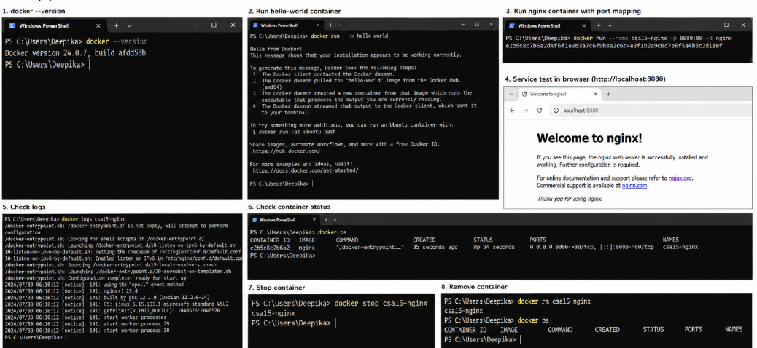

B. Capstone Module Decision
Capstone Module | VM / Container / Managed Service | Technical Reason
Frontend | Container | Easy deployment and scalability
Backend/API | Container | Lightweight and portable
Database | Managed Service | Secure and reliable storage
File storage | Managed Service | Cloud storage support
AI/Python module | Container | Dependency management
Analytics/dashboard | Container | Easy monitoring and updates
Notification/background job | Container | Runs independently

Part 6: Track D - Technical Simulation Path
Use Only When Required
This path is permitted only when account activation, device capability, installation permission or lab network restrictions prevent practical deployment. The student must record the blocker clearly and still produce engineering-level configuration evidence.
Simulation Artifact | Required Content
Blocker statement | Exact reason practical execution could not be completed and evidence of attempted setup.
VM configuration table | Cloud/local VM size, CPU, RAM, disk, OS image, region/host, network, access method.
Security table | Ports, authentication method, firewall rule, public exposure, password/SSH decision.
Snapshot/clone plan | Names, timing, retention and rollback purpose.
Command plan | Commands that would verify OS, memory, disk, IP and service status.
Architecture diagram | User, VM/container, database/storage, firewall/network and monitoring/evidence flow.
Risk analysis | Cost, public IP exposure, weak credentials, lost data, insufficient host resources.
Blocker Evidence and Justification

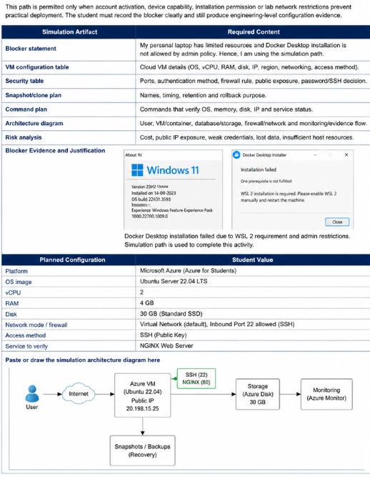

Planned Configuration | Student Value
Platform | Azure
OS image | Ubuntu Server 24.04 LTS
vCPU | 2
RAM | 8 GB
Disk | 30 GB
Network mode / firewall | SSH (22)
Access method | SSH Public Key
Service to verify | NGINX Web Server
Paste or draw the simulation architecture diagram here

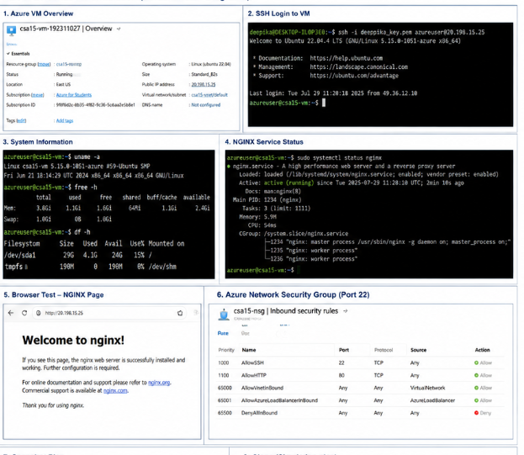

Part 7: Evidence Index, GitHub and Google Classroom Submission
The submission must be traceable. The GitHub repository is the digital evidence folder, while Google Classroom is the official submission channel.
Repository Item |  | Expected Content
README.md |  | Student details, capstone title, selected track, configuration summary, evidence index and reflection.
Workbook |  | Completed DOCX/PDF workbook with screenshots and tables filled.
Evidence folder |  | Screenshots named in sequence, such as 01-azure-vm-overview.png.
Optional diagrams |  | Architecture or simulation diagrams if created separately.
Reflection |  | Short note explaining what was learned and what will carry forward to CO2 AT3.
Evidence No. | File / Screenshot Name |  | What It Proves
1 | azure-login.png |  | Azure account login was successful
2 | azure-subscription.png |  | Azure for Students subscription is active
3 | vm-creation.png |  | Virtual machine was created successfully
4 | vm-overview.png |  | VM status, IP address and configuration
5 | networking-rules.png |  | SSH port configuration
6 | vm-stop.png |  | VM stopped successfully
7 | local-vm-settings.png |  | Local VM configuration details
8 | terminal-output.png |  | Linux command outputs
Checkpoint | Status |  | Evidence / Observation
Repository is created under student's GitHub account. | [ ] Yes [ ] Rework |  | GitHub repository was created successfully.
README.md is complete. | [ ] Yes [ ] Rework |  | README file contains all required details.
Workbook is uploaded. | [ ] Yes [ ] Rework |  | The completed workbook was uploaded successfully.
Screenshots are uploaded and named clearly. | [ ] Yes [ ] Rework |  | Screenshots were uploaded with proper names.
Google Classroom submission contains the GitHub repository link. | [ ] Yes [ ] Rework |  | The GitHub repository link was submitted in Google Classroom.
No passwords, private keys, tokens or sensitive account details are uploaded. | [ ] Yes [ ] Rework |  | No sensitive information was uploaded.
Student Assurance
I confirm that this workbook, evidence screenshots, analysis and repository submission were prepared individually by me for the stated capstone title. I have not uploaded passwords, tokens, private keys or sensitive account information.
Student Name | M Deepika
Register Number | 192311027
Signature | M Deepika
Date
Faculty Verification
Faculty Name | Dr. C. Rajesh Babu
Employee ID | SSETSCS-415
Verification Remarks
Signature / Date
Reference Links Used in This Workbook
Azure for Students: https://azure.microsoft.com/en-us/free/students
Azure for Students offer details: https://azure.microsoft.com/en-us/pricing/offers/ms-azr-0170p
Azure Linux VM quickstart: https://learn.microsoft.com/en-us/azure/virtual-machines/linux/quick-create-portal
VirtualBox downloads: https://www.virtualbox.org/wiki/Downloads
VMware Workstation and Fusion: https://www.vmware.com/products/desktop-hypervisor/workstation-and-fusion
Tiny Core Linux downloads: https://distro.ibiblio.org/tinycorelinux/downloads.html
Alpine Linux downloads: https://alpinelinux.org/downloads/
Alpine virt ISO directory: https://dl-cdn.alpinelinux.org/alpine/latest-stable/releases/x86_64/
Debian netinst: https://www.debian.org/download
Debian network install: https://www.debian.org/CD/netinst/
Ubuntu Server: https://ubuntu.com/download/server
Docker Desktop: https://www.docker.com/products/docker-desktop/

